

NetLinx Module Interface Specification

For the

Escient PowerPlay
DVD Changer
X-Y Control

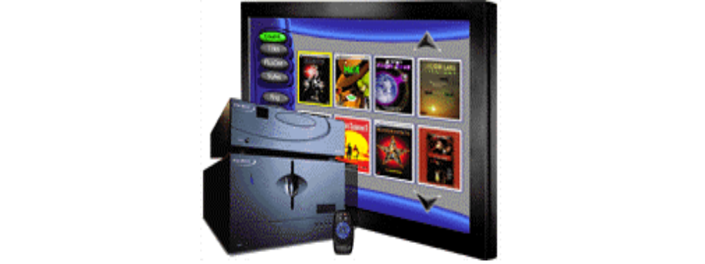
TABLE OF CONTENTS

Introduction 3
Scope 3
Overview 3
Implementation 3

Introduction

This is a reference manual for use by anyone wanting to interface between an AMX NetLinx system and an Escient PowerPlay DVD Changer. The PowerPlay has a proprietary (non-standard) protocol that can be used to communicate and configure the unit. Communication takes place directly over the built in communications port. The port is connected to the serial port of a NetLinx controller.

Scope

There are more capabilities supported by the PowerPlay protocol than are implemented. This was an intentional decision. The intent is to make the interface as generic as possible so all interfaces from NetLinx to digital audio servers will share the same protocol. The AMX interface to a PowerPlay limits the protocol to those commands that an end-user would most likely use and would most likely be supported by other DVD changers.

Overview

The PowerPlay may be controlled using the AMX Escient PowerPlay X-Y NetLinx module. This module requires a single serial port connection from a NetLinx serial port to the PowerPlay being controlled and a VGA connection to the controlling touch panel. For installations containing more than one PowerPlay, multiple instances of the module with multiple physical RS-232 ports and VGA connections may be used. The module implements the actual PowerPlay protocol for communicating to the unit.
The programmer will interface to the NetLinx module by passing the through a virtual device. This virtual device is defined by the programmer and is used to control the DAS-750 PRO and receive status updates from the DAS-750 PRO.

The following diagram gives a graphical view of this interface.
Escient
PowerPlay
Escient
PowerPlay
Module
NetLinx
Program
Virtual
Device

Implementation

To interface to the Escient PowerPlay X-Y module the programmer must do each of the following:
- Define the NetLinx serial port id that will be used to communicate to the PowerPlay.
- Define the touch panel id the module will use to communicate with the main program.
- There is a touch panel file (PowerPlay X-Y.tpd) and main program (Escient PowerPlay X-Y Test.axs) already created by AMX for testing.
- The NetLinx Escient PowerPlay X-Y module must be included in the program with a DEFINE_MODULE command. This command starts execution of the module and passes in the following key information: NetLinx serial port id of the PowerPlay unit, the device id of the touch panel, the X level of the joystick, The Y level of the joystick, and the channel id of the joystick button.

An example of how to do this is shown below.

DEFINE_DEVICE
dvPOWERPLAY = 5001:1:0 // PowerPlay Serial Port
dvTP = 128:1:0 // touch panel

// MUST DEFINE JOYSTICK CHANNEL AS SHOWN BELOW. CHANNEL NUMBER CAN CHANGE.
DEFINE_VARIABLE
INTEGER nX_LEVEL
INTEGER nY_LEVEL
INTEGER nJOYSTICK_CHAN = 125

// DEFINE THE LEVELS
DEFINE_START
CREATE_LEVEL dvTP,1,nX_LEVEL
CREATE_LEVEL dvTP,2,nY_LEVEL

// START THE MODULE
DEFINE_MODULE 'Escient PowerPlay X-Y' modPPXY(dvPOWERPLAY,
dvTP,
nX_LEVEL,
nY_LEVEL,
nJOYSTICK_CHAN)

Upon initialization the module will communicate with the unit and information will be exchanged.

